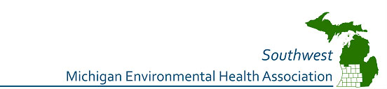

2015 Fall Executive Board

President – Blake Walters, MS, REHS

Environmental Health Specialist

Allegan County Health Department
3255 - 122nd Ave. Ste. 200
Allegan, MI 49010

Phone: (269) 686-4558
Email: bwalters@allegancounty.org

Vice President – Carol Balkon, REHS

Environmental Health Specialist

Barry-Eaton District Health Department

330 W. Woodlawn

Hastings, MI 49058

Phone: (269)-798-4106

Email: cbalkon@bedhd.org

Treasurer – Megan Griffin

Sanitarian

Kent County Health Department

700 Fuller Ave NE

Grand Rapids, MI 49503

Phone: (616)-558-7415

Email: Megan.Griffin@kentcountymi.gov

Secretary – Jodi Trantham, REHS

Environmental Health Specialist

Barry-Eaton District Health Department

330 W. Woodlawn

Hastings, MI 49058

Phone: (269)-798-4104

Email: jtrantham@bedhd.org

First Member at Large – Ann Schrader
Public Health Sanitarian- Plan Review
Public Health Muskegon County
209 East Apple Ave.
Muskegon, MI 49442
Phone: (231)724-4582 Office
Email: SchraderAN@co.muskegon.mi.us

